Business Case

for

FoodFriends

Prepared by Prince Bhatia

FoodMedia Ltd

27 Mar. 17

# Table of Contents

Table of Contents ii

1. Assumptions iii

2. Executive Summary iv

3. Business Case 1

3.1. Project sponsor(s) and stakeholder(s) 1

3.2. Business needs 2

3.3. Business requirements 2

3.4. Business value 2

3.5. Special issues or constraints 3

4. Appendices 4

4.1. Appendix 1: Tool 1 4

4.2. Appendix 2: Tool 2 4

5. References 5

Revision History

|  |  |  |  |
| --- | --- | --- | --- |
| **Name** | **Date** | **Reason For Changes** | **Version** |
| Prince Bhatia | 26th March 2017 | Initial draft | 1.00 |
| Prince Bhatia | 27th March 2017 | Final copy | 1.01 |

# Assumptions

* FoodFriends have a existing application but is restricted to Auckland region only
* Goal - want to expand from the local Auckland region to all throughout New Zealand with the mobile application
* Mobile application lacks the fundamental features only sell products from couple stores
* Only have small food retail stores on board not major supermarkets or farmers on board- not a diverse product range
* Have a specific amount of funds for this project
* Have a great team of engineers and marketers familiar in the technology space
* Large amount of people using mobile application within Auckland
* No other platform has been created like this using a mobile application on both apple and android
* Only one competition My Food Bag
* No charge to download the application
* New application will require less staff but more staff to initially build upon the existing system
* All board of directors are happy with the growth strategy chosen to grow the company
* Have a good reputable reputation in the Auckland area
* Customers needs

# Executive Summary

The overall ultimate goal for FoodFriends is to play their part in creating and supporting a society that is more sustainable and less wasteful (FoodFriends Assignment, 2017). This can be achieved through their three platforms they have, which are; offering a solution to shop for food online; have it delivered daily for freshness; organising and planning recipes and daily menus; and helping overcome the issue of food wastage in households (FoodFriends Assignment, 2017). The platform chosen to meet this goal is the platform to shop for online food. By purposing a mobile application called FoodFriends to update the current application for the solution to Ashley’s problem. The application will be for free as their current version is for free.

The reason for this project to be prioritised is because the concept of purchasing food online through the mobile application where food merchants are listed has been proven as a proof of concept. It is the perfect time to expand the applications functionality and to get more food merchants on board, onto the platform. The mobile application fulfils the business needs which is to be able to shop on one platform to purchase all food products from different stores. Ashley faced a problem where she could not get her Asian produce without visiting the store. The FoodFriends mobile application solves this by getting all food merchants to join the platform. It works by either entering a post code or taking your current location and displays what food merchants are closet to you to provide the freshest food available delivered. Customers can fill up their cart from multiple stores and then checkout conveniently. This solution fulfils the business need because the platform is a convenient solution because all food merchants are available, even speciality items, that can be purchased in a single cart. This solves the problem Ashley was facing where she could not purchase her speciality Asian produce without having to go in store. The purposed platform is different from other competitors because it has the ability to message food merchants. This feature allows you to communicate with the food merchant about knowledge of a product or future products. With this feature combined with out rating system which allows customers to rate the freshness, quality and overall price sets us apart from the competitors.

This solution for FoodFriends is a really great opportunity for the company to expand and fulfil the need of having a convenient mobile application where all food merchants are available. The client wants to improve and take their current app to the next level and become the leading market leaders in food shopping online. This can be achieved by creating a brand through marketing and a great functioning application with a large food merchant community supporting it. The mobile application combined with a great marketing team can achieve their goal and become a multi million dollar business.

# Business Case

## Project sponsor(s) and stakeholder(s)

**Project Champion**

**Ashley McQueen -** Chief executive officer (CEO) & Board of Director at FoodFriends

Ashley McQueen is the CEO of Foodfriends, she is responsible for managing the overall business processes and the company resources. In the business case Ashley works closely with the executive director Simon McQueen her husband, to communicate all her policy’s to the rest of the board. Ashley is the project champion for FoodFriends as she is knows all the processes and running of the business, which provides substantial insight for the project. She will needed to be approached often.

**Stakeholders**

**Employees**

**Ryan Fallon -** Head of Marketing

Ryan is head of the marketing team, who’s been assigned the task of promoting the app for potential customers and potential food merchants.

**Phillip Smith –** Software Engineer

Phillip is a graduated software engineer who is the head IT expert. He manages all the technical aspects of the mobile application and will oversee the development of the app.

The aforementioned mentioned employees are well trained in their fields. Ryan has a excellent background in marketing and has done a few large projects before joining the FoodFriends team. He is highly qualified with a masters in Commerce from the University Of Arizona. Phillip is a software engineer and has his team who created the current mobile app for FoodFriends. He is also a highly skilled engineer which a Bachelor of engineer honours from the University Of Sydney. With the current employees the project will affect both teams. Ryan wants more funding to be able to fund for a bigger team that are experts in the mobile application business. He also wants higher wages, as he will be taking on more responsibility and doing more work towards the marketing of the project. Phillip wants to hire more engineers and wants to just oversee the application making process. He too also want a increase in wages and funding for his bigger team.

**Customers**

Customers want a cheap and fast service to accommodate them when ordering food online. Customers also want to be in control where there food comes from and who’s supplying it. Retailers also want to know who their customers are, therefore can target them with specific products to increase their revenue.

**Board of Directors**

Six other members are also invested in the company FoodFriends who are also on the board of directors. They have invested in the company and are therefore stakeholders of FoodFriends. They want to see the benefit this project will bring and how much growth the company can expand too. The board of directors essentially just want the project to be successful and make the company fruitful.

**Project Sponsor**

**Simon McQueen -** Executive Director & Board of Director at FoodFriends

Simon Mc Queen is the executive director of FoodFriends. He is responsible for making sure it meets the business benefits and has managerial status. He works closely with his wife, Ashley, as she knows the processes and company resources. Simon is in charge of managing current and future projects including this current one and the execution of each project. Simon must ensure developing and gaining future growth for the company towards more profitability. For FoodFriends Simon is the project sponsor because he has the sign off authority, as this project is potentially a growth and profit opportunity for the company.

## Business needs

This project has been initiated to update FoodFriends existing mobile application to expand all over New Zealand. The business need is to bring all food merchants online. Ashley faced a problem of purchasing some Asian products in store which she could not purchase online. The mobile application solves this problem by bringing all niche stores online onto the platform. So mothers like Ashley can purchase speciality foods without leaving their home. The mobile app is live but only in one region, Auckland. They wish to expand all over New Zealand and become the market leaders in providing food online. There are current systems like food bag but they are limited to providing food for meals only and supermarkets like Countdown do not have speciality items that certain ethnic based retailers have. FoodFriends mobile application currently has small food merchants in local community’s on board which has acquired a lot of niche food merchants on board(Appendix 4.1).

## Business requirements

The mobile application will need to provide customers with the closest stores available to their given location on their phone. This will require some software coding to further develop the application. The location area should show them a list of food merchants from which they can purchase from and know how far away they are located. The mobile application will need to know if customers are in a rural or urban area and adjust the radius of the locality of food merchants accordingly. The specific functionality of the app must include the following. Firstly it must display the food merchants available to the customer in their given location. This can be either entered by a post code or use your mobiles location services to search for stores nearby. Secondly be able to purchase goods through the mobile app from multiple stores in one mobile cart. Thirdly pricing of the products will need to be competitive and sustainable. So Pricing will be controlled/discounted to promote usage of purchasing through the application. Fourthly, there needs to a review area. Where the rating of the quality, freshness and overall price can be rated, creating a trustworthy persona. Fifthly there needs to be a communication area where you can message the food merchants directly either to enquire about a certain product or ask additional questions about a product. Lastly, there must be a search function for the option to search up a certain store for a specific product. An example can be the Nosh food market store for organic products.

## Business value

It is expected as more food merchants join the FoodFriends platform more of the brand awareness will increase, therefore increasing revenue from using the mobile app (Appendix 4.2). By increasing the amount of food merchants more products will be available to existing customers and the big range will attract new customers (Appendix 4.2). The business value for FoodFriends this purposed solution is going to bring an estimate of 40% more purchases of the products food merchants have on offer (Austin, 2005). With the in house marketing team a trustworthy brand can be created, this means 36% will tell their friends and family about the experience they had with the mobile application (Austin, 2005). The value the mobile application brings immense value to the business solution, as it is more easier to access and view stores within the app with a larger range. The mobile application is also inter-transferable in the sense if they want to go global with their application they can do so quite easily.

## Special issues or constraints

The special issues of the purposed solution is the functionality of the mobile application. The mobile application will needed to be tested by users on a large scale to test all functionality is working before releasing it to the public. Therefore this will be costly as it is difficult to get organic users to provide feedback with an incentive. Lastly another special issue is educating the public on how to use the mobile application. FoodFriends will have to educate the public on how to use the mobile application as it has quite a lot of features which can only be shown through a demonstration or short video. Therefore more money is required to market on how to use the mobile application.

The constraints with the purposed solution are firstly in the rural community there is no retail atmosphere. Using our app in the rural area will alleviate to high costs because the cost of goods being transported will far outweigh the cost of goods. Therefore making it difficult for people who live on farms and away from retail districts. Secondly another constraint is the time it will take to become a trustworthy brand. This comes down to the marketing team and how customers perceive the mobile application. Therefore it could take a while before it can be seen as a safe and secure way to purchase on the platform. Lastly another constraint is the obligations some food merchants have with other larger retailers. For example they can only sell exclusively to super markets and have signed a contract which forbids them selling direct to the public. Therefore this could threaten the whole platform as in order for this solution to work a lot of food merchants have to get on board to support the idea of local, fresh food delivered.

# Appendices

## Appendix 1: SWOT Analysis

|  |  |
| --- | --- |
| **Strengths** | **Weakness** |
| * Great team of experienced staff * Large amount of investment to invest into application * Successful Auckland based concept * A lot of niche food merchants on board * Large amount of people using app * Good feedback/ reputation | * Worked in one location, might not work in rural community’s * Mobile application has to be combatable with all phones a lot of time and money spent in R & D(research and development) * Relies on partnering with lots of businesses dealing with food |
| **Opportunities** | **Threats** |
| * To add more food merchants * Ability to grow and expand the company globally * Create and support local communities | * More staff will be needed to hire as we expand throughout New Zealand * Need to educate people on how to use the mobile app * Bad product with food merchants, can’t monitor produce |

## Appendix 2: Fishbone Diagram

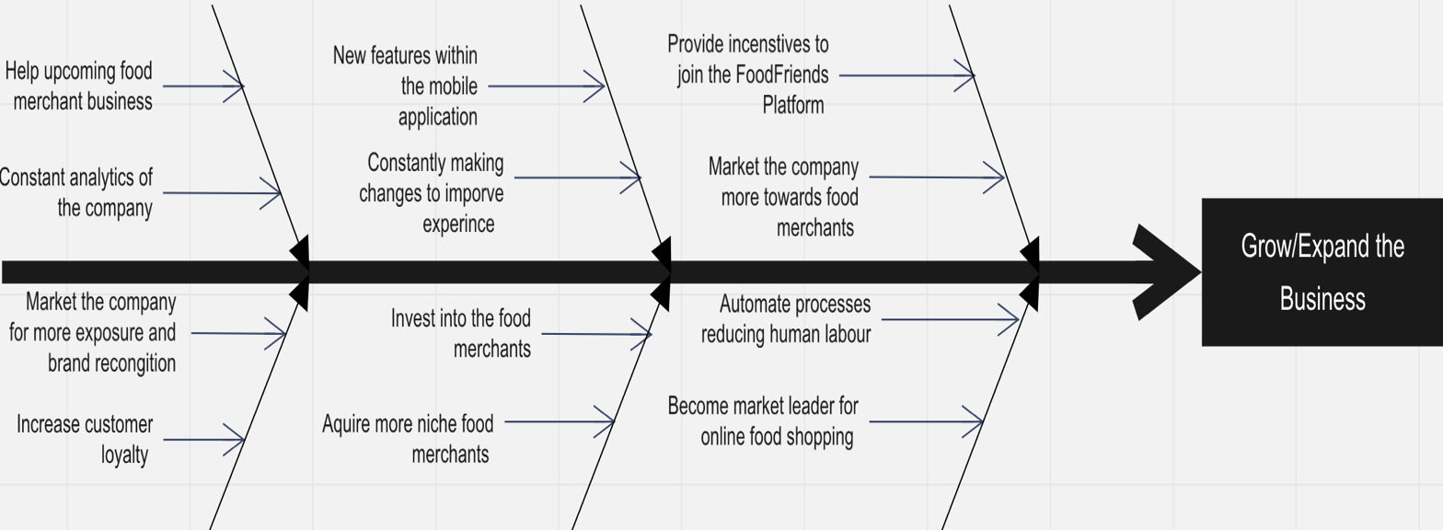

# References

M, Austin. (2012). Retail apps increase revenue. Retrieved from [*http://www.techradar.com/news/world-of-tech/roundup/retail-apps-increase-revenue-1079699*](http://www.techradar.com/news/world-of-tech/roundup/retail-apps-increase-revenue-1079699)

FoodFriends Assignment (2017). New Zealand: FoodFriends.